Instance Configuration with ORM Stack

Contents

1. Introduction 3
2. Workflow diagram to deploy the stack 3
3. Create stack for the Instance Configuration 4
4. Plan the Job 7
5. Apply the Job 9
6. Verify in the Console 10
7. Destroy the stack 11

Introduction
An instance configuration defines the settings to use when creating compute instances, including details such as the base image, shape, and metadata. User can also specify the associated resources for the instance, such as block volume attachments and network configuration, and user can associate the instance with a capacity reservation.

Workflow diagram to deploy the stack
Below diagram shows how the Terraform Artifact are applied in the OCI. While creating a ORM stack, using terraform deliverables Init, Plan and Apply is the flow to provision the resource in the OCI. We can have the deliverables in any of below.
- GitLab/GitHub Repo
- Bitbucket
- Can be in folder/.zip in the local disk
- Object Storage Bucket
- Can be in compartment
- Oracle provided Template


Create stack for the Instance Configuration

Go to OCI Console Developer Services Resource Manager Stacks select the compartment Create Stack

My Configuration Folder Browse Select the “instance configuration” folder that contains the terraform Upload.

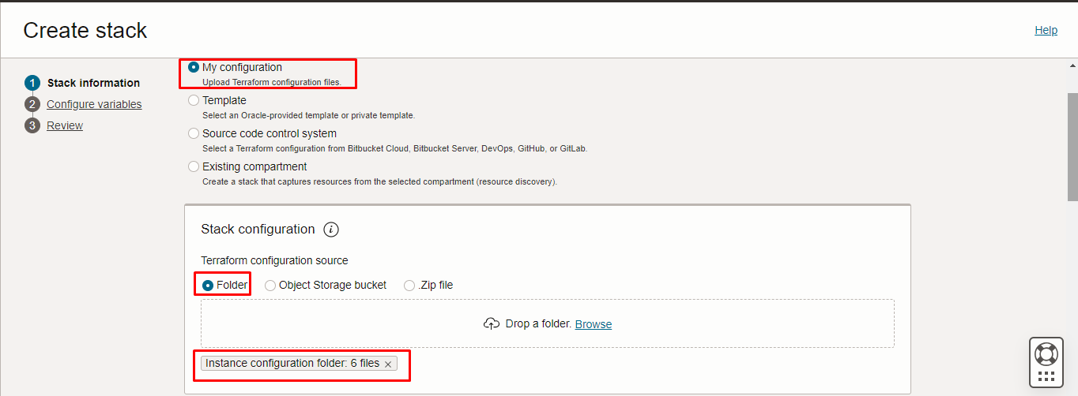
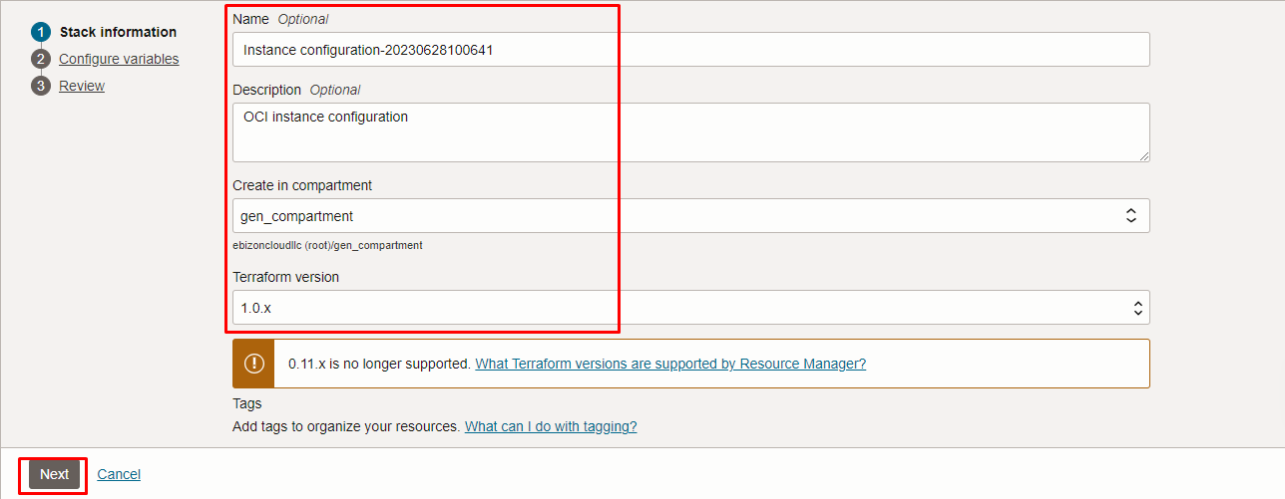

Click “NEXT”

Select the parameters as per the below screen,
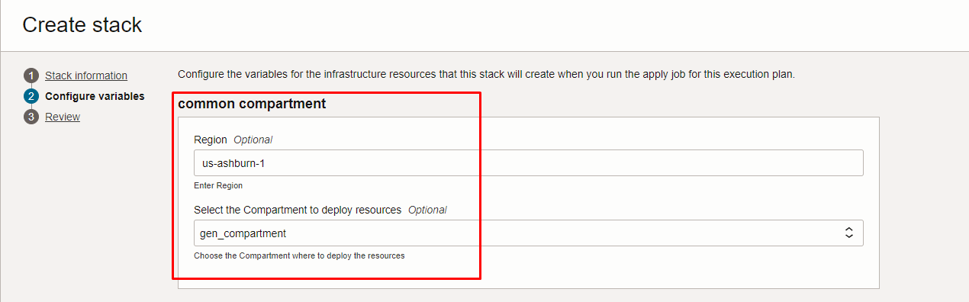
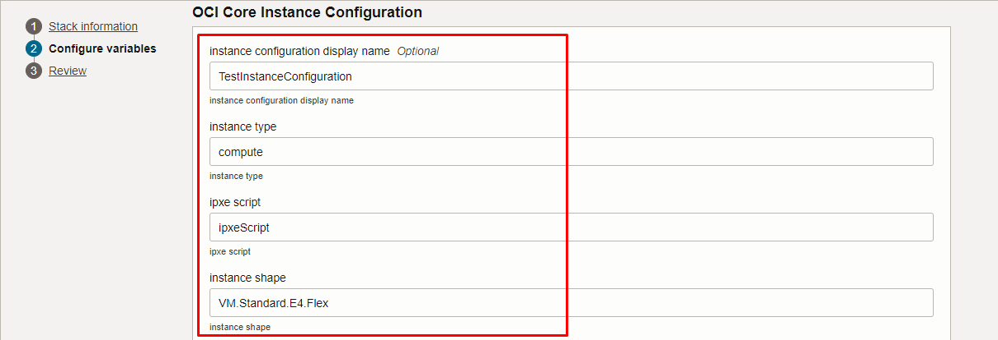
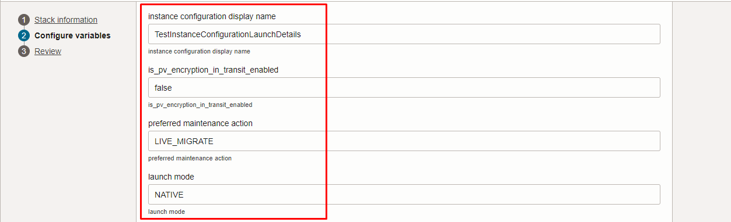
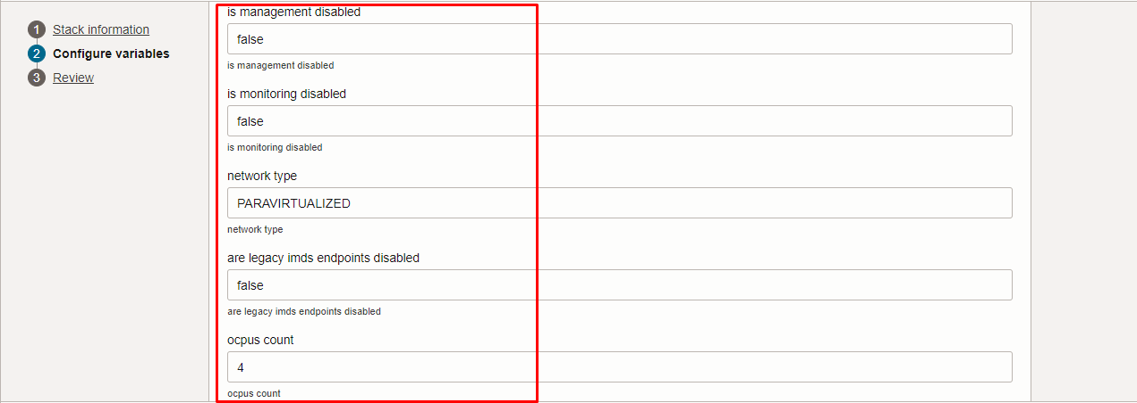
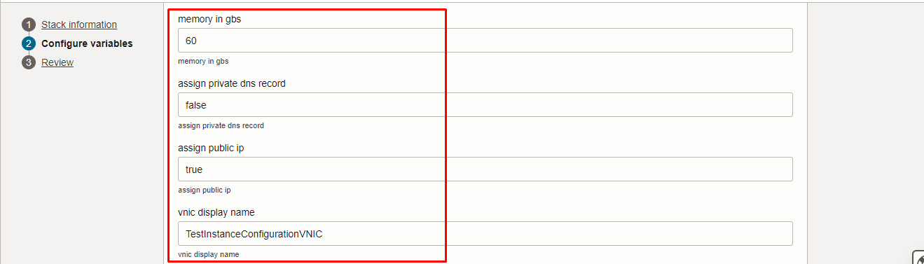
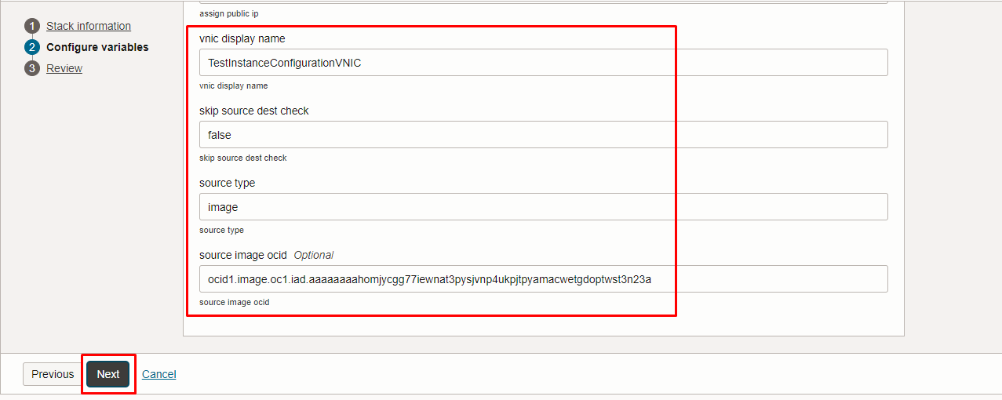
Click “NEXT” Click “CREATE”

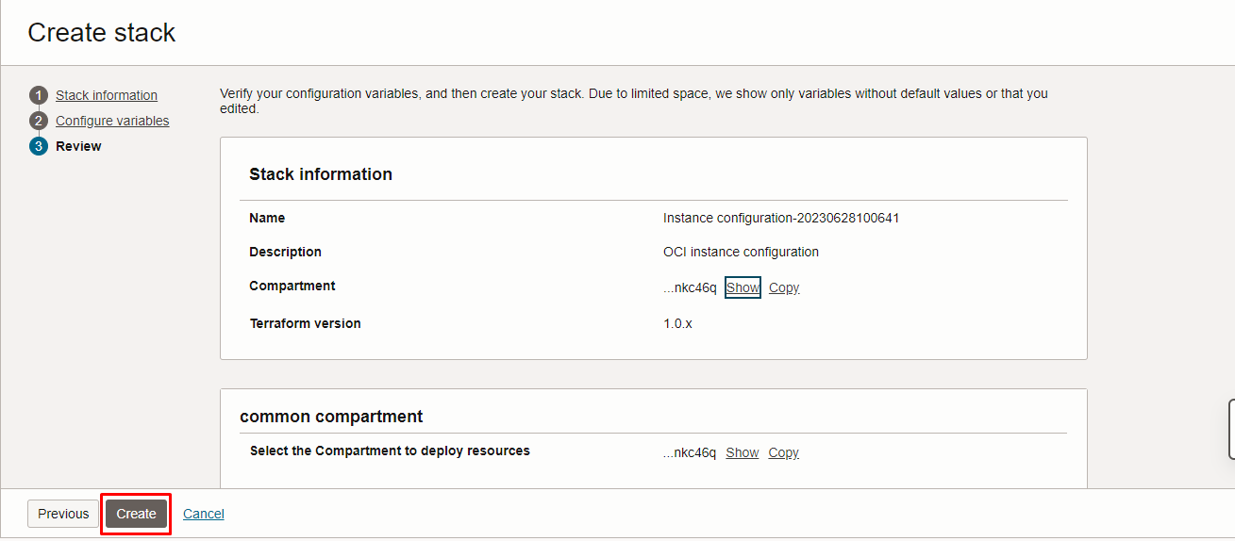

Plan the Job

Click the “Plan”
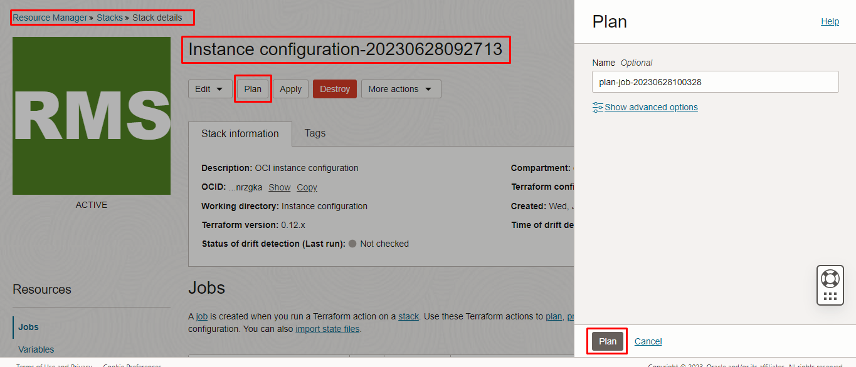

Verify the Plan is successful.

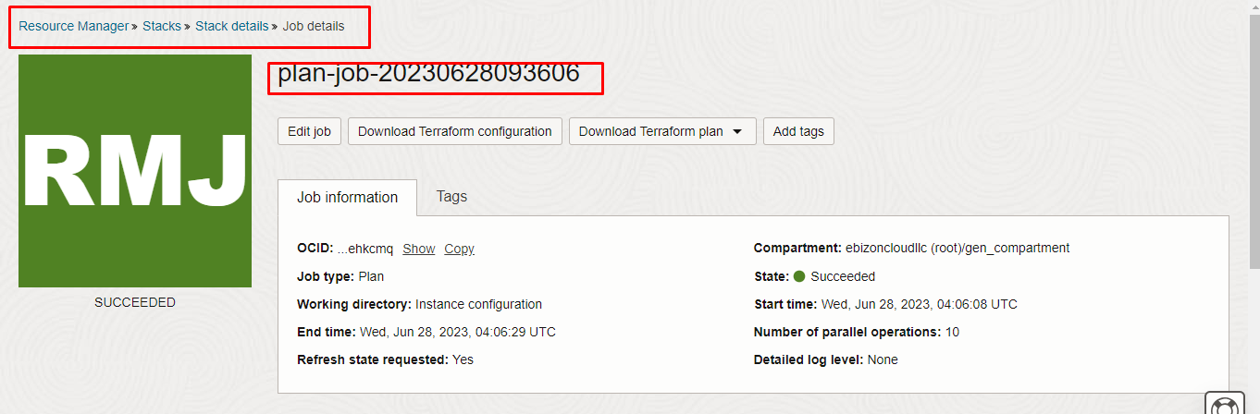
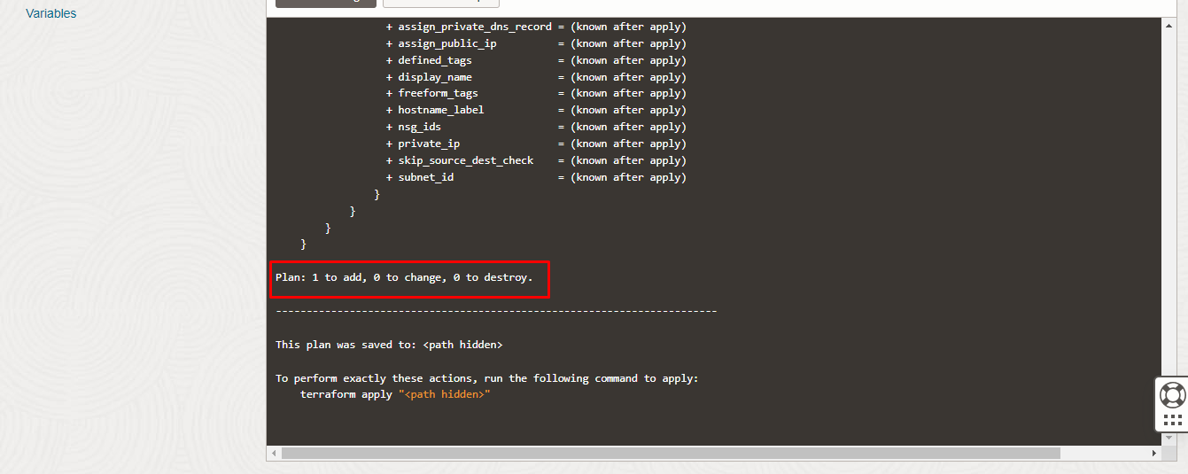

Apply the Job

Once the “plan” is success, now click “Apply”

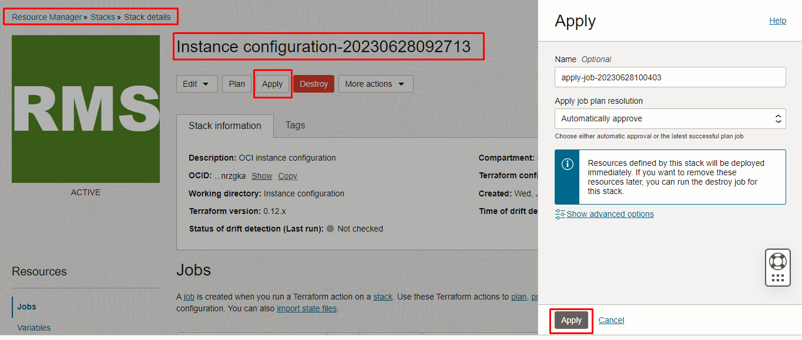

Verify the Apply is successful.
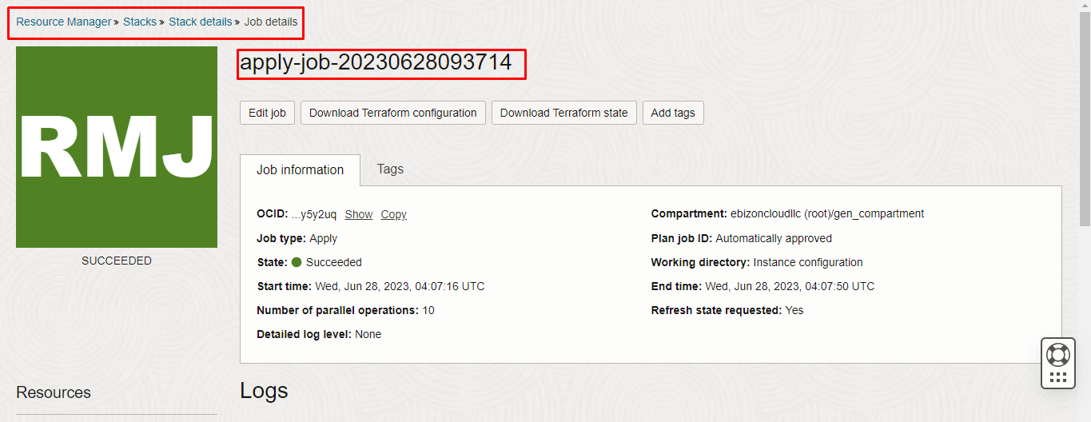
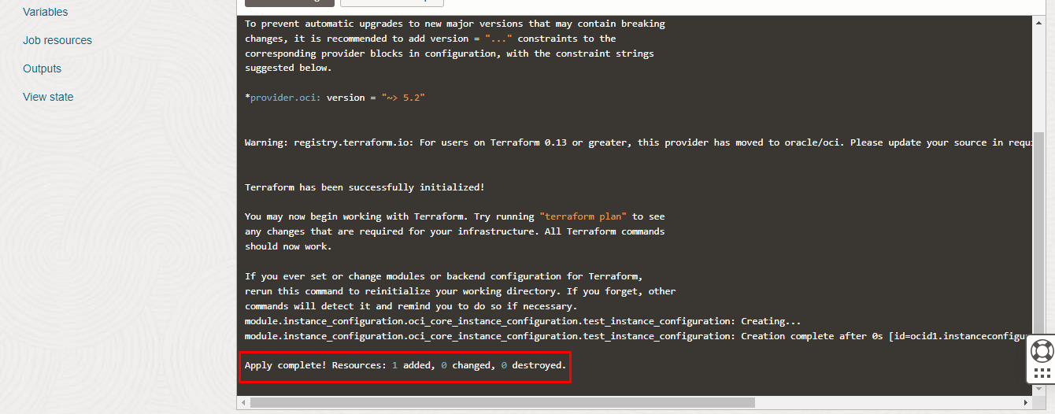

Verify in the Console

Go to OCI Console Compute Instance Configuration
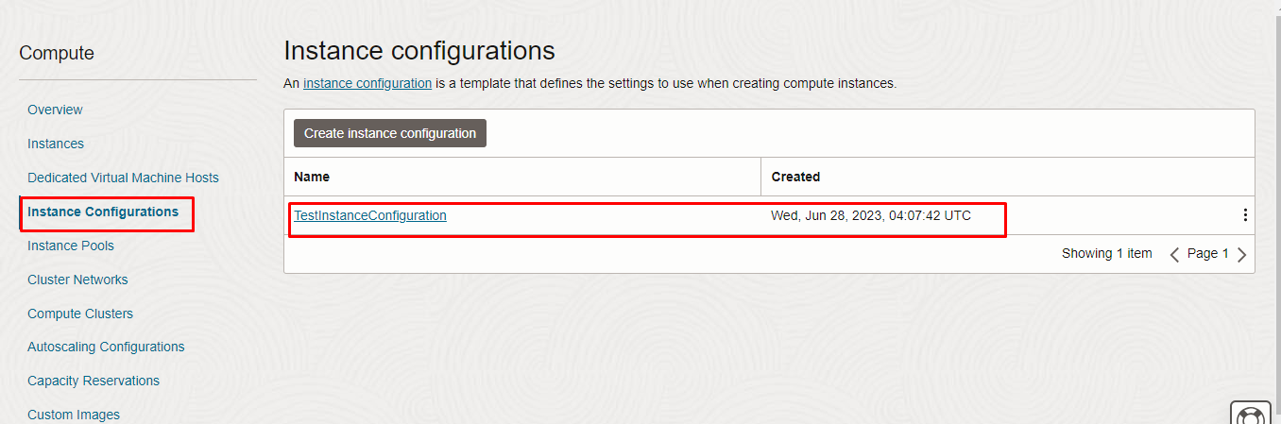

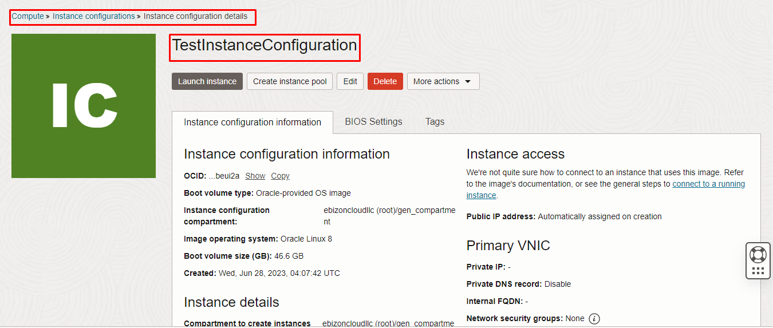
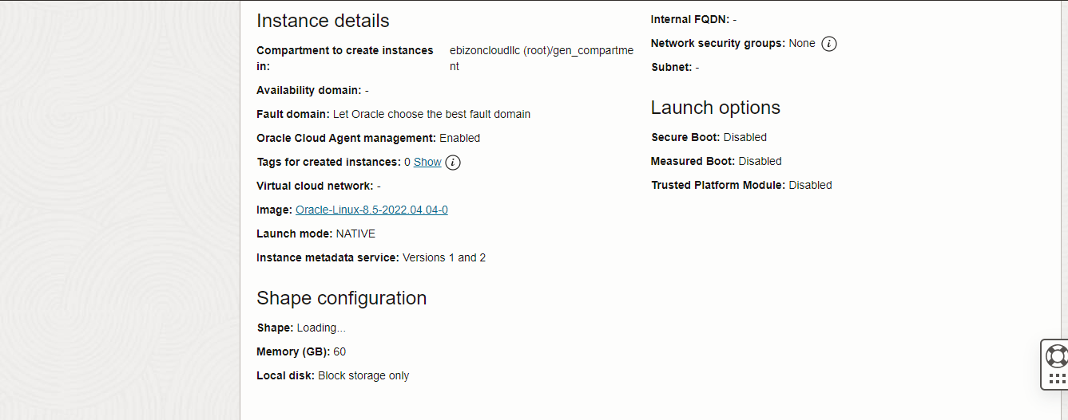

Destroy the stack

Create a destroy job in Resource Manager to release resources associated with a stack and clean up the tenancy. Once destroyed data cannot be recovered from resources.

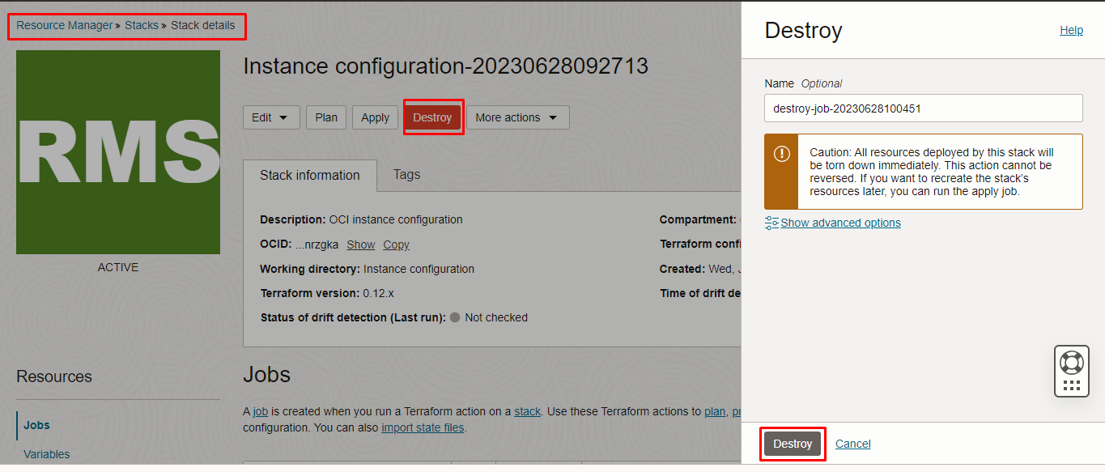

#########END############

